Url :- https://x63trqsv3yzfu.mocha.app/

I'll check 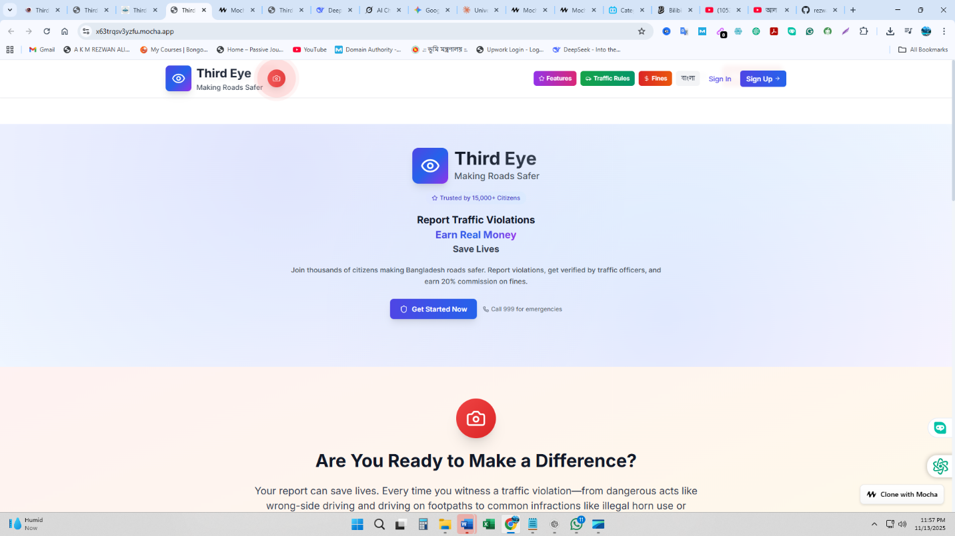the database and fix the demo account login issue right now.
✅ Demo Account Fixed!
I've completely recreated the demo account with the proper credentials. You can now login with:
Phone: 01712345678
Password: password
The account now has:
- ✅ Verified user status
- ✅ Complete KYC (identity + biometric verified)
- ✅ Wallet setup (bKash)
- ✅ Sample reports and earnings
- ✅ Full demo mode features
Try logging in now - it should work perfectly!

